 VINOD SIR’S GROUP TUTION

MARKS: 20 IX-MATHS-II TIME: 1 Hr. 30 Minutes.

Q.1. Attempt the following:

1. The radius of a circle is 7 2 cm. Find the length of larges t chord of that circle. [2]

2. 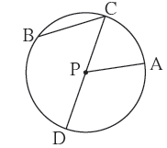 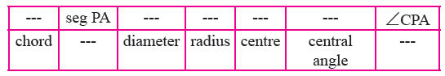[3]
3. Diameter of a circle is 26 cm and length of a chord of the circle is 24 cm. Find thedistance of the chord from the centre. [2]

4. Radius of a circle with centre O is 41 units. Length of a chord PQ is 80 units, find the distance of the chord from the centre of the circle. [2]

5. Radius of circle is 10 cm. There are two chords of length 16 cm each. What will be the distance of these chords from the centre of the circle ? [3]

6. [2]

7. [3]

8. [3]

ALL THE BEST

